Peptic ulcers

Introduction:

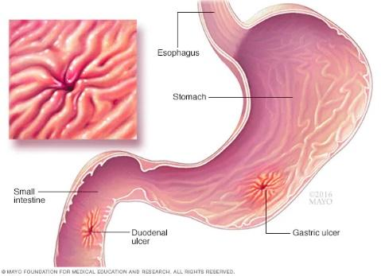Definition and Overview:

An ulcer is the occurrence of an erosion or wound at the lining end of the leaky wall in the first part of the small words or at the bottom of the esophagus. It is the formation of open ulcers that affect the lining of the stomach and the upper part of the small intestine. The most common symptom of peptic ulcer is stomach pain. In most cases, the pain is more pronounced.

Historical Context:

Peptic ulcer disease has occurred in many stages, as there are concepts that link it to bacteria and psychological factors

Now, ulcers are treated in a more advanced way due to current research and innovation. The first case of stomach ulcers was documented in the nineteenth century, and in the twentieth century, surgical treatment and antibiotics were found, and modern developments are looking for a newer treatment than antibiotics.

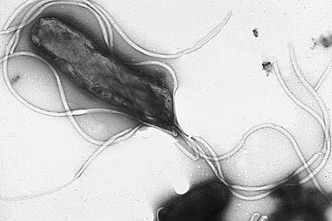Epidemiology:

Stomach ulcers are widespread and affect millions of people every year, and they occur among all groups, especially adults between the ages of 30 and 50. The rates of stomach ulcers vary from one place to another, but they increase in developing regions compared to developed countries, as infection rates increase in low-income areas. Where pollution increases, lack of cleanliness and purity of water, and eating habits also have a factor, such as taking medications without the advice of a doctor, and smoking, which affects not only the stomach, but also every cell in the body.

Etiology:

Causes and Risk Factors:

The most common causes of peptic ulcers are infection with Helicobacter pylori (H. pylori) and long-term use of nonsteroidal anti-inflammatory drugs (NSAIDs) such as ibuprofen (Advil, Motrin IB, others) and naproxen sodium (Aleve). Stress and eating spicy foods do not lead to peptic ulcers. However, they can make your symptoms worse. Peptic ulcers occur when acid in the digestive tract erodes the inner surface of the stomach or small intestine. The acid can create a painful open sore that may bleed.

The digestive tract is lined with a layer of mucus that normally protects it from acid. But if the amount of acid increases or the amount of mucus decreases, you may develop an ulcer.

Genetic and Environmental Influences:

Genetic and environmental factors are factors for stomach ulcers, as having a family history of stomach ulcers increases the risk of developing them. Some studies also indicate that there is a genetic predisposition to ulcers due to genetic mutations that affect stomach secretions or immunity. As for the environmental effects of infection with Helicobacter pylori bacteria: infection with this bacteria is the main cause of stomach ulcers. It is transmitted through contaminated water, food, or personal contact. Also, taking excessive antibiotics irritates the stomach lining. Also, spicy foods, caffeine, alcohol, and smoking increase the risk of stomach ulcers. From what we have explained, we understand that genetic and environmental factors can be a cause of stomach ulcers, so we have to be more restrictive in our diet and habits.

Clinical Features:

Signs and Symptoms:

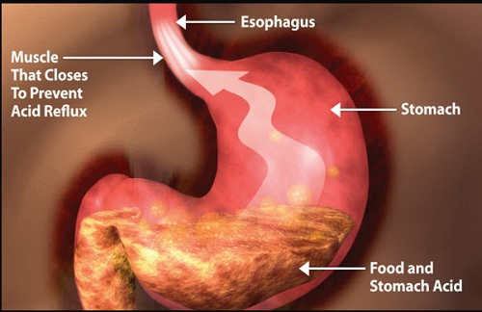Many people with ulcers have no symptoms, but some may experience:

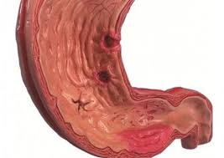Burning pain in the upper abdomen (the abdomen between the breastbone and the navel). Stomach pain and heartburn. Indigestion and belching.

Feeling full and bloated, weight loss, fatigue, exhaustion, frequent vomiting, loss of appetite. Symptoms of stomach and duodenal ulcers may resemble other digestive problems, and here lies the importance of differential diagnosis

Disease Stages and Progression:

The development of a stomach ulcer begins with the irritation of the stomach lining due to Helicobacter bacteria. Then this development begins to erode the lining of the stomach. This severe erosion begins to form an ulcer and leads to severe pain, especially after eating.

Complications:

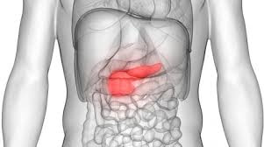After suffering from a stomach ulcer, complications occur that may be life-threatening if the matter is not controlled, which are:

Vascular bleeding in the stomach or small intestine, perforation of the stomach or small intestine, obstruction of the gastrointestinal tract, which prevents the transfer of food from the stomach to the duodenum, and anemia due to bleeding

Diagnosis:

Diagnostic Criteria:

Review the symptoms mentioned previously and see if they recur. We must also conduct a physical examination Measure pulse and blood pressureCheck for abdominal pain when applying pressure

Diagnostic Tests and Procedures:

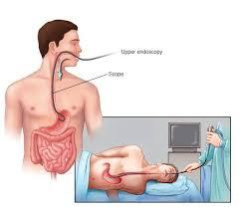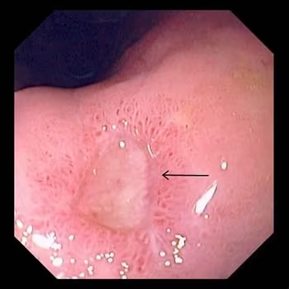If these symptoms are repeated, we must take these measures to avoid complications. We may do a gastroscopy or endoscopic examination, which is a tube that enters from the mouth and is equipped with a camera at its end to transmit the image directly to the screen so that the doctor can see the stomach.

Or we do a urea breath test, a urea breath test, and a urea breath test, through which helicobacter bacteria can be detected.

Stool analysis can also reveal Helicobacter bacteria or occult blood

Blood tests also reveal bacteria or anemia that may be caused by peptic ulcers. All of these diagnostics help us detect peptic ulcers.

Differential Diagnosis:

The symptoms of a stomach ulcer can be mistaken for another disease, and they can be identified by using tests such as endoscopy, ultrasound, and CT scan. Those diseases that can overlap with a stomach ulcer in symptoms are :gastritis, esophageal reflux, pancreatitis, and stones. Gallbladder and stomach cancer

Pathophysiology:

Mechanisms of Disease Development:

A peptic ulcer develops as it burrows deep into the lining of the stomach or duodenum (the first part of the small intestine). An ulcer develops when the natural defense mechanisms in the lining of the stomach or duodenum weaken, making the lining more susceptible to damage by gastric acids.

Cellular and Molecular Changes:

Cellular and molecular changes due to stomach ulcers include inflammation of surrounding cells, increased acid secretions, and inflammatory cell activity. The ulcer also increases the secretion of cytokines, which are proteins that act as chemical messengers between cells. These cytokines enhance the inflammatory response and contribute to tissue damage. However, infected cells attempt to activate molecular pathways for repair, such as growth pathways and cellular signaling, to rebuild the damaged mucosal lining.

Impact on Body Systems:

Stomach ulcers have effects on the body, as they cause internal bleeding, which can be acute or chronic. In severe cases, the ulcer can lead to perforation in the stomach. It can also lead to anemia due to bleeding, which leads to weakness and shortness of breath.

Management and Treatment

Medical and Surgical Treatments:

In severe cases or those that do not respond to treatment, surgical operations are performed, including Partial Gastrectomy, in which part of the damaged stomach is removed. Vasotomy, which is cutting the nerves that stimulate acid, or the ulcer can be removed directly, or a procedure can be performed. Pyloroplasty, in which the opening between the stomach and intestines is widened so that food passes easily and reduces pressure on the stomach.

Pharmacological Therapies:

Stomach ulcers can be treated with medication

Proton Pump Inhibitors (PPIs)

* Omeprazole
* Lansoprazole
* Reduce stomach acid production.

H2 Receptor Antagonists (H2 blockers)

* Ranitidine
* Famotidine
* Reduce acid production.

Antacids

* Aluminum Hydroxide and Magnesium Hydroxide
* Calcium Carbonate
* Neutralize stomach acid and relieve pain.

Mucosal Protective Agents

* Sucralfate
* Misoprostol
* A black background with a black square

  Description automatically generated with medium confidenceProtect the stomach lining.

Antibiotics (to treat H. pylori infection)

* Clarithromycin
* Amoxicillin
* Used together for 10-14 days.

Lifestyle and Dietary Modifications:

Ulcers can be treated by changing lifestyle, reducing foods and drinks that increase symptoms, such as hot tastes and caffeine, also reducing smoking and drinking alcohol, and avoiding medications and antibiotics that harm the stomach lining, such as (NSAIDs). You must also maintain a healthy weight, and it is important to follow up with a doctor to ensure complete recovery

Rehabilitation and Supportive Care:

Rehabilitation and supportive care include several measures, such as modifying the lifestyle by eating healthy, reducing the consumption of food and beverages, quitting smoking and alcohol, working to manage stress, regular medical visits to monitor the condition, learning to use medications with caution, and educating the patient about the importance of treating ulcers. And the risk is doubled.

Prevention and Control

Primary, Secondary, and Tertiary Prevention Strategies:

Prevention strategies include three levels: primary prevention, which aims to prevent the occurrence of ulcers by educating about the causes of ulcers and the importance of avoiding the causes that cause them, working to eat balanced meals, and reducing the intake of anti-inflammatory drugs. One of the most important things is ensuring that the food, water, and place are clean.

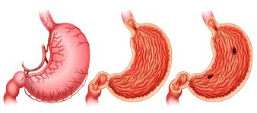As for secondary prevention, we must visit the doctor regularly to examine the digestive system and conduct tests to detect H. pylori infection and treat it with appropriate antibiotics. And use preventive medications against ulcers and bacteria.

The third is triple prevention, which aims to reduce the complications of ulcers by finding the appropriate treatment, adhering to it, and surgical intervention if necessary.

Public Health Interventions:

In public interventions, health care facilities must be improved and equipped with modern equipment. Conduct awareness seminars on the danger of ulcers and their complications, and ensure the safety of food and water, especially in villages.

Vaccination and Screening Programs:

Among the vaccinations that you should be careful about taking are those against H. pylori infection:

Challenges and developments: To date, there is no globally approved vaccine against H. pylori bacteria, but there is ongoing research to develop an effective vaccine. Vaccination could significantly reduce ulcer rates if developed successfully.

Vaccination against viruses that affect the digestive system:

Viral hepatitis: Hepatitis A and B vaccination is part of routine vaccination programs in many countries. These vaccines can help prevent liver problems that may affect overall health and the digestive system.

Rotavirus: The rotavirus vaccine is important for children to prevent severe diarrhea and gastroenteritis, which improves the overall health of the digestive system.

Prognosis

Disease Outcomes and Survival Rates:

Survival rates: Most cases recover completely with treatment if an early diagnosis is made, but if it is not diagnosed early, it will face serious complications such as bleeding or perforation. Surgical operations may be needed, which further complicates predictions.

Factors Influencing Prognosis:

Several factors affect the prediction, including: Early detection increases the likelihood of improvement faster and the effectiveness of medications and surgical interventions. Young and healthy people also have better results. Complications such as bleeding in an ulcer or the spread of stomach cancer negatively affect the prediction.

The patient's adherence to treatment has a significant impact.

Quality of Life:

Stomach ulcers affect the quality of life, as they cause constant pain, weight loss, and bleeding. Also, chemotherapy and radiation therapy can lead to side effects, and anxiety may cause psychological and behavioral effects such as depression.

Current Research and Future Directions

Recent Advances and Discoveries :

Recent advances in the treatment of ulcers include improved medications such as new proton pump inhibitors (PPIs) and H2 antagonists

And new drugs such as anti-H. pylori: new drugs such as rifabutin.

Antioxidant medications: to protect the stomach lining. And treatment with vectors, which are medications that target specific molecules

Ongoing Clinical Trials :

Experiments have been conducted on new medications, such as acid suppressants, and innovative treatment strategies have been developed, such as developing less effective NSAIDs and creating nutritional supplements that maintain the health of the humoral diet.

Future Research Needs:

Using advanced imaging technology to diagnose the disease more accurately and studying the impact of the microbiome: its effect on the development of ulcers.

Improving quality of life:

Managing side effects: Improve pain and nausea management.

Quality of Life Studies: Psychosocial support to improve quality of life.

Case study:

Case : Acute Gastric Ulcer

Patient: A 45-year-old male with a history of heavy NSAID (non-steroidal anti-inflammatory drug) use.

Symptoms: Severe upper abdominal pain, nausea, and vomiting.

Diagnosis: Endoscopy reveals an ulcer in the gastric mucosa. H. pylori testing is negative.

Treatment: Discontinuation of NSAIDs, proton pump inhibitors (PPIs), and antacids. Healing is monitored with follow-up endoscopy.